Introduction

1. Goal is to build a “Skill Management SaaS” (B2B)
2. Basically, such a software is used to help companies identify and track employees’ skills
3. Typically, the customer currently uses customized solutions
4. These solutions have some problems and inefficiencies
5. Customer segment- Software/IT Services
6. Users- HR/WMG personnel, employees looking to make internal switch
7. Such a product- if created with a smooth and high utility UX for the employee side- can help a company increase employee satisfaction and happiness thus reducing attrition and reducing organization costs

Uses of Skill Management software:

1. Workforce planning
2. Talent acquisition and onboarding
3. Performance management
4. Learning and development
5. Career development
6. Succession management
7. Compensation management

More comprehensively:

1. Help leaders analyse ability of their teams
2. Map required and desired skills to a job profile
3. Identify skill gaps that exist in various teams
4. Help formulate organization’s talent management strategy
5. Assist in fabricating strategies on succession planning, training and development programs and recruiting campaigns
6. Filter employee database by certain skills to assemble employees who have expertise in certain desired areas
7. HR staff uses it to maintain compliance with regulations that require businesses to provide evidence of their employees’ capabilities and certifications
8. Track expenses and ROI of employee trainings

Problem

1. Outdated skill definitions and taxonomies
2. Low reliability of employees “skill expertise level” data
3. Siloed system

Problem 1 - Outdated skill definitions

1. This can be mitigated by adding a feature that “notifies” (via mail and in-app notifications) the admin to check and update skills and definitions after a certain period of time
2. A feature that allows for “edits” to be suggested by employees while they are setting up their “talent profiles” via email and in-app notifications to the admin
3. If viable, an AI based system can be deployed that updates definitions itself by dynamically interacting with trusted sources

Problem 2 - Low reliability of skill data

1. Deploy a “skill rating system” that considers several factors to come to a final “skill proficiency number/percentage”, example:
   1. Calculate 1st score on time bound tests generated randomly from a big pool of question bank on a particular skill- this would reduce internal cheating from employees who’ve already pursued the test
   2. Conduct a pre-decided ‘n’ no. of such tests and take the average of the scores
   3. Add additional “skill points” for candidates with proven hands-on experience on a skill either via client project or mock projects
   4. A portion of skill points can come from manager recommendations on a particular skill
   5. For technical skills, integrations with programming platforms such as “leetcode”, “kaggle” etc. can be useful

Problem 3 - Siloed systems

1. Create seamless integrations with other HR softwares (check integrations section) using APIs

Key activities

1. Create a centralized database of skills
2. Enable admin users to map specific skills to job roles
3. Track the skills of individual employees
4. Identify employee skill gaps
5. Allow admins to search for employees with specific skills
6. Generate reports/dashboards to analyse skills, skill gaps and financials related to training and developing the workforce
7. Build a employee side profile page where the employee can enter necessary details themselves, and also visualize their career trajectory and roadmaps

Challenges

1. Migrating data from currently used SMS by organisations
2. Seamless integrations with HCMS (Human Capital Management System), Corporate LMS (Learning Management System), PMS (Performance Management System), company’s email client (Eg Outlook)
3. Competitive subscription based pricing
4. Facilitating reliable 24x7 customer support

Key features

The application would have 2 parts- “Admin” and “Employee”. Admin would be for HR and leaders of the organisation, and Employee would be for the employees to enter information and interact with.

The employee panel will help foster an engaging and thriving **skill social network**.

1. *For “Admin” panel*
   1. **Activity log / Notifications**- To receive daily summarized data on any manual changes in the database like an employee submitting scores of assessments/self-assessments, skills acquired on their previous projects, etc. via alert based notification button
   2. **AI global search**- An AI based “company global search” feature to find employees with specific skills
   3. **Filter**- To filter the employees on the basis of:
      1. Minimum skill proficiency needed (like “3 out of 5 stars needed in Python” etc.)
      2. Minimum hands-on experience with a skill (like “3 years” etc)
      3. Such a filter can either be in built in the search bar or be used after a search has been processed or both
   4. **Dashboard and reports**- The user should be able to visualize data on *skills, skill gaps, training, financials, external talent hired (and vet it against preset targets), training and skill development drive performance etc* and should be able to see trends on the basis of time, extrapolate and generate reports of the same
   5. **SSO**- For all softwares in the HR suite management
   6. **Role based access controls**- Providing appropriate Read and Write access features to personnel with respect to their position
   7. **Employee persona** feature that allows the user to enter several fields on ‘skills’, ‘total experience’, ‘sub-skills’, ‘experience with a skill’, ‘education’ etc. and fetch employees that “firmly” or “loosely” conform to these fields
   8. AI powered “**automatic employee recommendation system**” for internal vacancies
   9. AI supported “**succession planning recommendation system**” to recommend best suited employees for pivotal positions should they be needed to replaced
   10. An employee skill can contain a collection of **sub-skills** with a score/percentage displaying how well-versed is the employee with that subskill
   11. The above feature (in point ‘j’) would be of critical utility when sub-skill level strength is preferred for an assignment
   12. This would also give a more comprehensive insight into an employee skill strengths and weaknesses
   13. **Mailing client integration** to inform/remind selected employees to attend trainings and skill development paths before deadlines
   14. The above set of features (in point ‘m’) would be critical to ensure employee readiness before a set deadline set in accordance with a client project or a company goal
   15. 24x7 customer support
   16. A “**similar candidates**” feature that shows employees with a profile similar to the one searched
   17. A “favourite or ‘star’ button” or a “add to ____ list” button on the candidate profile tiles to shortlist candidates for a particular need
   18. **Key integrations**- HCMS, corporate LMS, PMS and mailing client
2. *For “Employee Talent Profile” panel*-

This should be an employee specific page that contains:

* 1. **Basic profile data**- Very similar to a social media’s profile page, with data on the employe like
     1. Name
     2. Picture
     3. Seniority and position in the organisation hierarchy
     4. About (written by the employee)
     5. Work experience- In previous and current organisation
  2. **Skills with skill rating**- Ratings should be on a numbered scale (like 1-10) which should be measured using highly reliant criteria like skill assessment tests, previous hands-on experience with a skill
  3. **Recommendations**- Best manager/higher management recommendation and client commendations
  4. **Skill interests**- Options provided by the admin, but this section should be filled by the employee
  5. **Career goals and aspirations**- This will motivate the employee to work towards defined goals and increase employee engagement, satisfaction and retention
  6. **Performance**- A section summarizing previous performance reviews
  7. **Position and project recommendations**- Recommendations on the employee profile page for positions and projects based on their set career goals, aspirations and previous experience
  8. **Wishlist and save for later**- To save opportunities, just how it is done while using our most favourite e-commerce apps
  9. **Career Paths**- Career paths showing complete hierarchy flow for a job profile and where the employee is currently on it, if he/she is following that career path
  10. **Visual career timeline**- A time based timeline denoting an employee’s previous experiences and showing the “future” portion inline with goals, aspirations set by the employee and on the basis of career paths selected/shown most interest in
  11. **Skill addition and definition updation suggestions**- Which would be pursued by the employee via email client integration and notification alert which would be received by the admin (HRs and leaders)
  12. **Search bar**- For employees to look up other employees and see what they’re up to.

Integrations

1. **Core HR software or HCM** (like Paylocity)- Core HR software holds all employee related data and documents and uses that data to identify trends with a holistic view of the organisation. Therefore, it is essential for SMS to seamlessly integrate with it, and update employee information dynamically.
2. **Corporate LMS** (like SAP Litmos)- Corporate learning management systems facilitate access to a centralized library of up-skilling, cross-skilling and training content for employees. They also store training progress and performance records- this information should dynamically interact with the SMS to get updated data on employee skills. Such integration would also allow for the administration to create customized training programs for different employees, attributing to their different skill-sets and strengths-weaknesses
3. **Performance management systems** (like ADP Workforce Now)- PMS enables organizations to track and manage employee progress, performance, and development in relation to organizational goals, client requirements and industry trends. PMS and SMS integration would allow managers and leaders to factor in previous year/quarter skills acquired, trainings completed to evaluate the employee exhaustively.
4. **Email client**- Integration with email clients (like Outlook) is needed to generate automatic yet customized mails to employees with reminders on trainings, skill development opportunities for upcoming client projects etc.

PS:

1. It’s important to note here that most of this can be accomplished by one standalone solution, like **Paylocity** which provides a single source of truth for all the aforementioned softwares
2. Such a software allows for module to be purchased separately in case the complete product is not required

Feature prioritization

Features that enable the completion of main tasks would take precedence over the rest, and would be a part of the MVP:

1. For “admin” side:
   1. AI global search
   2. Filter
   3. Dashboard and report generation (on skill gaps, trainings, training performance etc.)
   4. All key integrations (as mentioned in “Integrations” portion)
2. For “employee talent profile” side:
   1. Basic profile data
   2. Skills with skill rating
   3. Skill interests, career goals and aspirations
   4. Key integrations
   5. Performance summary

-The above mentioned features are key, rest should be validated and developed at later stages.

-In the future, the “MVP product” can be offered as a free product, with other features included as a part of paid subscription packages.

Challenges to selling

1. The software must justify entropy in the form of expenditure of time, money and learning curve to replace the existing system
2. For an organisation not using a solution currently, the ROI such a system brings to the company should be more than the cost incurred
3. Some clients would find several features as excessive and would want those to be removed
4. The aforementioned problem can be solved by offering some features as optional which would come with different subscription package

Wireframes

Admin side:

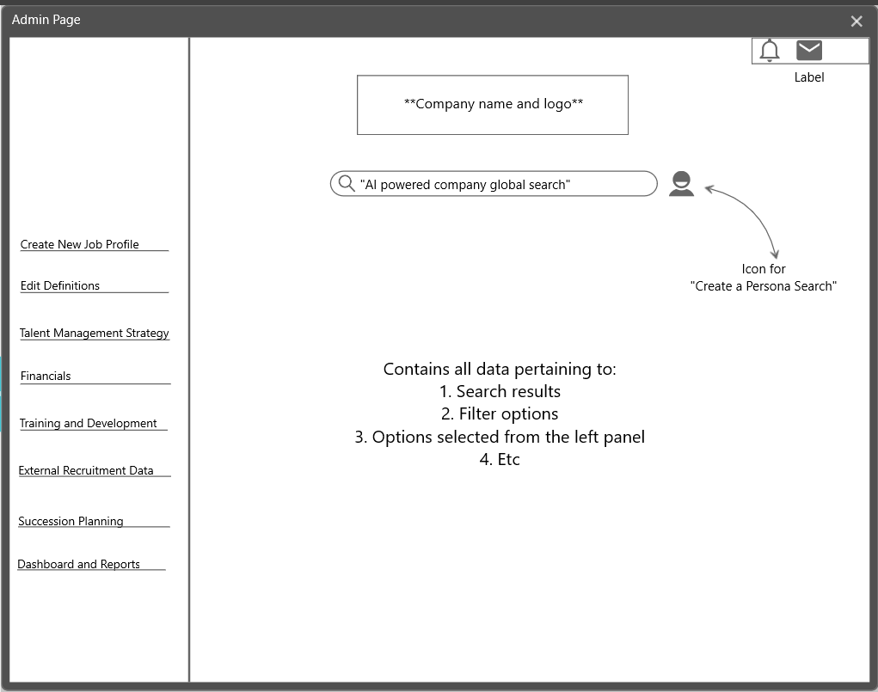

Employee side:

